The following processes are part of the yearly administration required to keep the Core|Time system up to date.

Contents
1. Overview 1
2. Extend System Calendar 1
3. Extending Company Holiday Schemes 4
4. Extend Balance Calendar 4
5. Complete Balance Period End 5

Knowledge Article: Calendars Knowledge Article

Extend System Calendar
The Core|Time System Calendar must be extended each year to cover the next calendar year. Before extending the System Calendar check and make note of the following items (per T&A Company):

- Start day of the Company (e.g. Monday)
- Last period configured on the System Calendar
- Number of weeks in the year

Navigate to: System Params > Calendars > System Calendar

- Select the Company from the LOV.

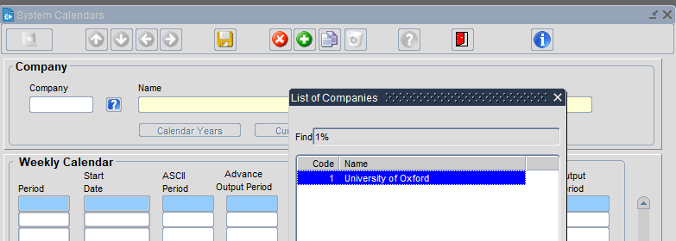

- Click ‘Calendar Years’.

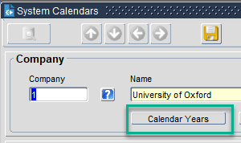

- Scroll to the bottom of the list, click on the last entry and click on the green + in the toolbar to insert a new row

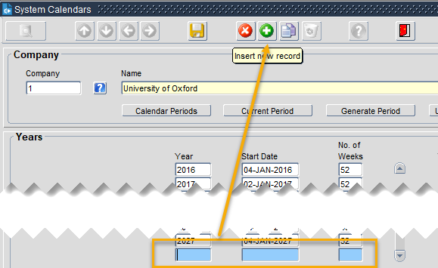

- Enter the relevant details as follows:

Year - Enter the year that you are configuring e.g. 2023

Start Date - Enter the start date in the format DD-MMM-YYY

 | NB: The start date must correspond to the 'Start Day' configured for the Company. For example, if the start day of the Company is Monday then the start date of the calendar must be a Monday.  The start date of the new calendar year must be exactly one week after the start date of the last period of the previous year. It is important to ensure that all weeks are covered i.e. that there isn't a gap between the end of one year and the start of the next.

No. of Weeks - Specify the number of weeks in this year e.g. 52 or 53.

- SAVE

 | NB: The current system is configured to and including 2027.

- Click 'Calendar Periods'.

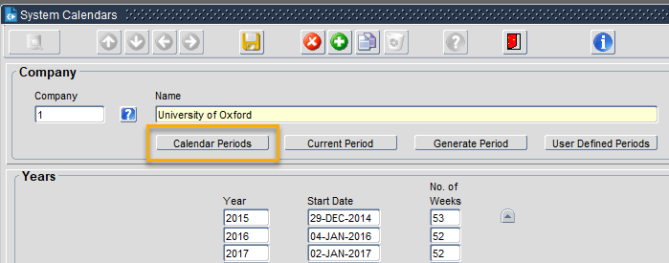

- Click ‘Generate Period’.

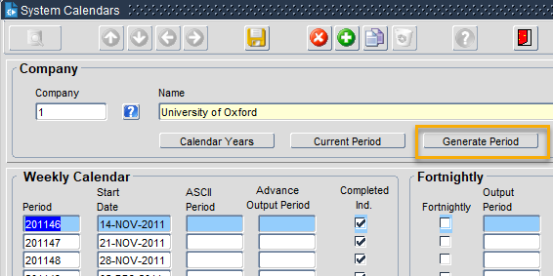

- Enter End Period for the year you've just added e.g. 202352 and press enter to auto-populate the Start Date and End Date for the final period of the newly added year.
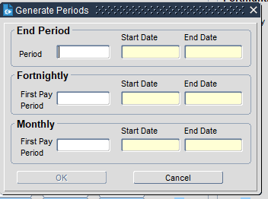

- Click ‘OK’ to automatically generate all weekly periods for the year.

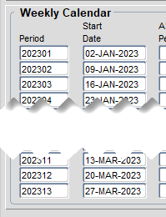

Extending Company Holiday Schemes

See Portal Guide – HOW TO – Maintain Bank Holiday Schemes in the Portal.

Extend Balance Calendar

Navigate to: System Params > Balances > Calendars

- Select the balance calendar to be extended from the LOV.

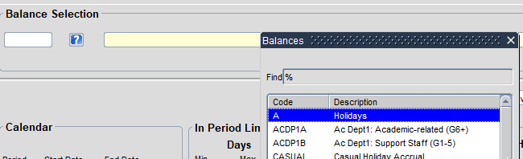

- In the next available row enter the following details:
Field | Description
Period | Enter the balance period number. For yearly periods, enter the full year e.g. 2023. For shorter periods, enter the year followed by 01, 02 etc.  For example, 2023 for Annual Leave, 202301 for Time in Lieu
Start Date | Specify the start date of the period (e.g. annual leave year 01-OCT-2023)
End Date | Specify the end date of the period (e.g. annual leave year 30-SEP-2024)
End of Period Limits
For the following settings make sure the 'Carried Forward' option is selected in the 'Controls for' drop down.
Days – Max | If applicable, specify maximum number of days that can be carried forward into the next balance period. e.g. Carry forward max 5 days
Hours – Max | If applicable, specify maximum number of hours that can be carried forward into the next balance period. e.g. Carried forward max 37.5 hours

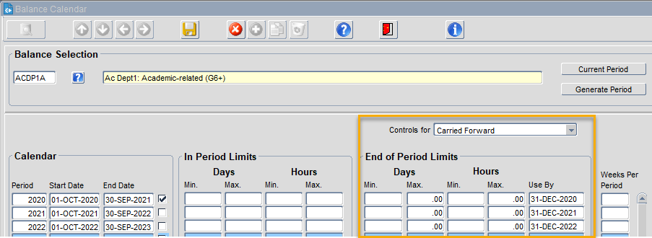

- SAVE.

- Repeat these steps for all balances.

Complete Balance Period End
At the end of the entitlement/balance year, Balance Calendars must be closed to:

• Calculate new entitlements
• Apply Length of Service adjustments.
• Process carried forward values

Before the balance period end is completed the following must be true:

- System Calendar is up to date.
- Balance Calendar exists in CoreHR
- Carried Forward limits applied to Balance Calendar
- Balance Calendar has been extended to at least one future Balance Period.
- Entitlements, Length of Service values up to date
- Balance Calendar Period end date has passed. e.g. To close the 2022-23 leave year the current date must be after 1 Nov 2023
- HR staff have run reports showing the outstanding leave balance for individuals so that leave to be carried forward can be calculated and input.

Navigate to: CoreTime > Period End > Balance Period End

- Select the Balance Calendar from the LOV.

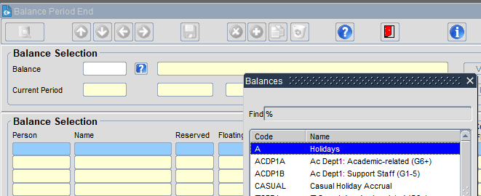

- Review the dates in ‘Current Period’

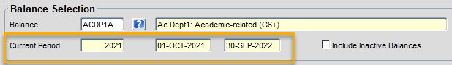

- Click ‘View Thresholds’ to ensure Carried Forward limits are as expected.

- Click ‘x’ to close the window.

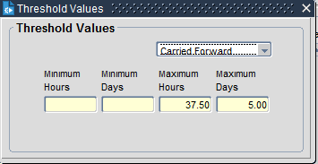

- To close Current Period, click ‘Run Period End’.

- Click ‘Yes’

- To override carried forward limits per individual employee, tick ‘Ignore’.

 | NB: Our configuration is for all balances to have 0 days leave carried over and any agreed carry over to be input by HR teams in the new year. There should be no need to ‘ignore’ any of the carried forward limits at this stage.

- Exit to complete Balance Period End.

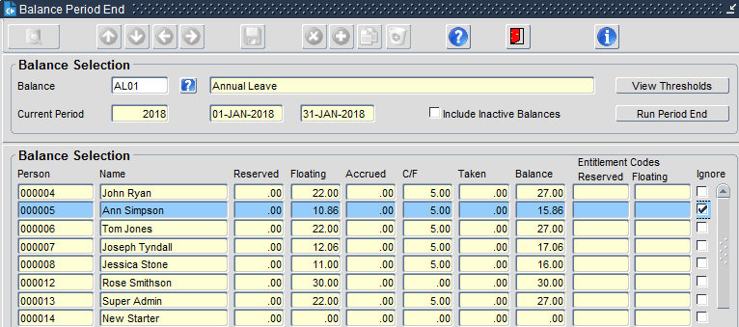

To ensure that all employees can view their full entitlement once the rollover has been completed the following steps must be taken, or the overnight calculation processes should re-calculate balances for all staff.

Core|Portal > WFM Admin Dashboard > Balance Maintenance

- Locate the balance you wish to recalculate and click on the ellipses (…) at the end and choose 'view'.

- The From Period* will auto-populate with the rolled over period and the relevant dates will display

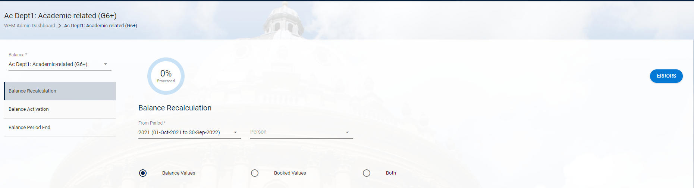

- Select the “All” (Both??) radio button

- Click RECALCULATE

- Say Yes to the confirmation message

- The button status at the bottom of the screen changes to Recalculating….

- If there any errors which need to be actioned you can check these on the Errors Screen-click on ERRORS

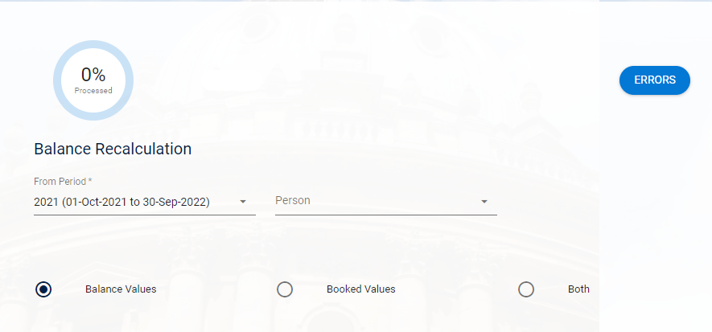

- Any errors will be listed on the screen.

- Repeat these steps for all balances that have been rolled over. (The system will re-calculate all balances for the balance code selected.)

